**Abstract**

The “Word Jumble Game” is an interactive text based puzzle game where players must unscramble jumbled words. It has various features, including user registration and login, a multi-level gameplay structure with increasing difficulty, a scoring system, a leaderboard, and an admin panel for user and leaderboard management. The game is designed to enhance vocabulary and problem solving skills, with options for clues and limited attempts to make it more challenging.

**Features and Implementation Details**

**Welcome and Instructions**

The game begins with a welcome message and a brief tutorial explaining the rules:

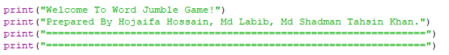

Figure : Code for welcome message

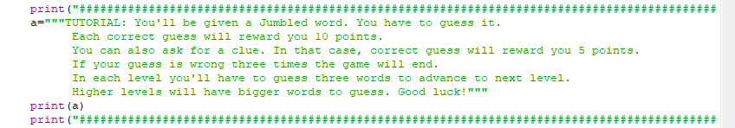

Figure : Code for game tutorial

Players are informed about the scoring system, the use of clues, and the consequences of incorrect guesses. This ensures that players understand the objectives and gameplay before starting.

**Registration System**

Players can register by providing their name, email, and password. The system checks for duplicate usernames and stores user information in a file. This feature ensures unique player identification and provides secure access to the game.

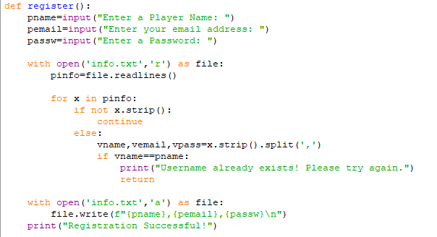

Figure : Code for unique user registration

**Login System**

Registered players can log in using their username and password. The system verifies credentials against stored data. Upon successful login, players can start the game or access additional features such as the leaderboard. This feature ensures a personalized experience for each player.

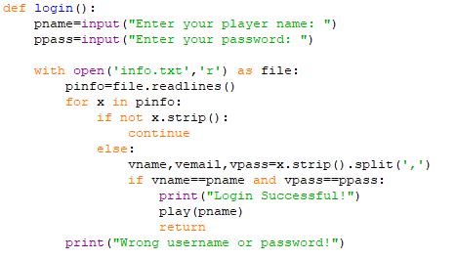

Figure : Code for correct user login

**Gameplay Mechanics**

The game is divided into multiple levels, each requiring players to guess a set number of words to progress. The difficulty increases with higher levels, featuring longer words. Players earn points for correct guesses, with reduced points if a clue is used. A limited number of incorrect guesses adds a layer of challenge. The player's score and progress are saved at the end of the game.

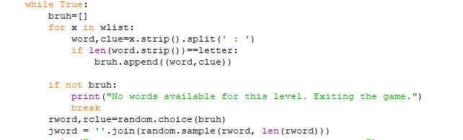

Figure : Code for creating random jumbled words

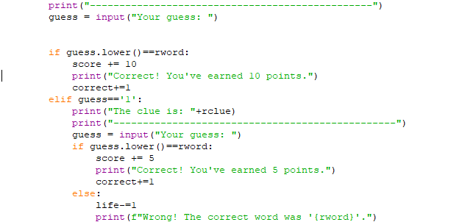

Figure : Code for scoring and validating correct guess

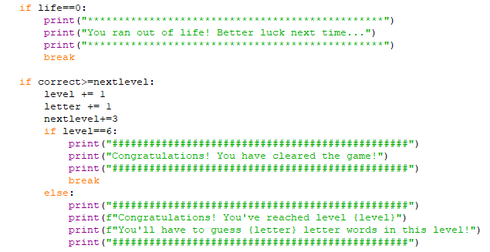

Figure : Code for ending game and leveling up

**Scoreboard**

Player scores are recorded and displayed on a leaderboard. This feature fosters competition and allows players to track their performance relative to others.



Figure : Code for updating scoreboard

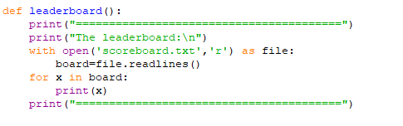

Figure : Code for displaying scoreboard

**Admin Panel**

The admin system enables management of user information and the leaderboard. Admins can view and edit player details and oversee game statistics. This feature ensures smooth management and maintenance of the game.

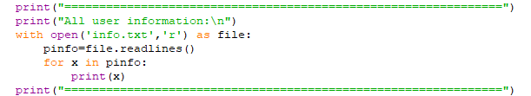

Figure : Code for displaying all user info

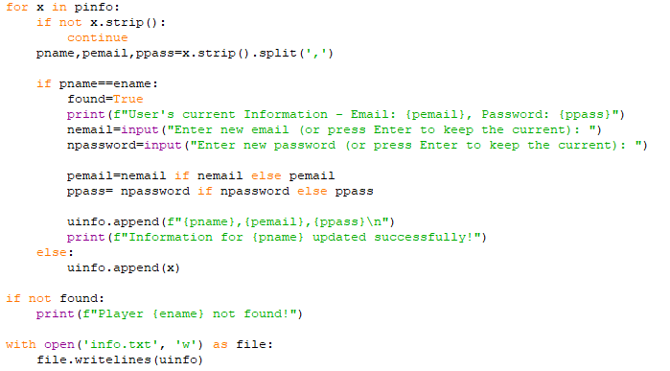

Figure : Code for editing user info

**Exit and Flexibility**

Players and admins have the option to exit the game or their respective menus at any time. This ensures user convenience and enhances the overall experience.



Figure : Code for exit

**Conclusion**

The Word Jumble Game is a application that combines fun and learning. It offers a seamless experience with well defined gameplay, user management, and an admin system. The use of files for data storage ensures persistence across sessions. Each feature has been designed to enhance user engagement and maintain the simplicity of use.